**GRE实验**

**实验8-2 GRE实验**

**学习目标**

* 了解GRE协议原理。
* 配置GRE实现私有网络跨越公网通信

**原理**

GRE(Generic Routing Encapsulation)即通用路由封装协议，是对某些网络层协议(如IP和IPX)的数据报进行封装，使这些被封装的数据报能够在另一个网络层协议(如IP)中传输。

GRE是VPN(Virtual Private Network)的第三层隧道协议，即在协议层之间采用了一种被称之为Tunnel(隧道)的技术。

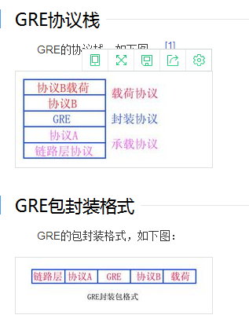

**拓扑图**

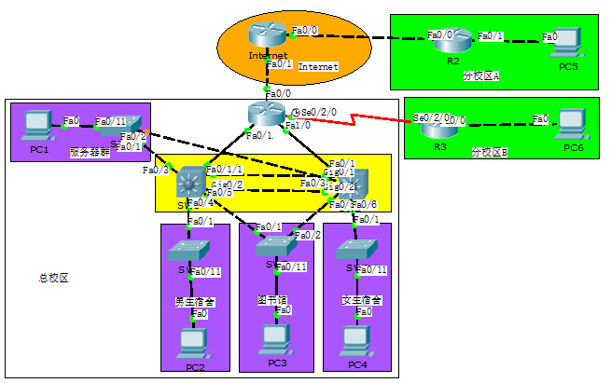

图1拓扑

**操作步骤**

将《PPP实验》中保存的拓扑打开， 总校区中出口路由器R1和分校区A的路由器R2都已经接入了Internet ，可在两台出口路由器上部署GRE VPN实现总校区和分校区A之间的互联互通。

1. 配置GRE
2. R1上配置GRE协议

|  |
| --- |
| *R1>enable*  *R1#conf t*  *R1(config)#interface tunnel 0 //创建隧道接口*  *R1(config-if)#ip add 10.0.130.133 255.255.255.252 //配置隧道IP地址*  *R1(config-if)#tunnel mode gre ip //设置隧道为GRE*  *R1(config-if)#tunnel source fastEthernet 0/0 //设置隧道源IP*  *R1(config-if)#tunnel destination 200.0.0.2 //设置隧道目的IP* |

1. R2上配置GRE协议

|  |
| --- |
| *R2>enable*  *R2#conf t*  *R2(config)#interface tunnel 0 //创建隧道接口*  *R2(config-if)#ip add 10.0.130.134 255.255.255.252 //配置隧道IP地址*  *R2(config-if)#tunnel mode gre ip //设置隧道为GRE*  *R2(config-if)#tunnel source fastEthernet 0/0 //设置隧道源IP*  *R2(config-if)#tunnel destination 100.0.0.2 //设置隧道目的IP* |

1. 在R2上对tunnel对端地址进行ping测

|  |
| --- |
| *R2(config-if)#do ping 10.0.130.133*  *Type escape sequence to abort.*  *Sending 5, 100-byte ICMP Echos to 10.0.130.133, timeout is 2 seconds:*  *!!!!!*  *Success rate is 100 percent (5/5), round-trip min/avg/max = 1/3/5 ms* |

1. 在R1和R2之间部署OSPF，实现总部和分校区A互联互通
2. 在R1上配置OSPF

|  |
| --- |
| *R1(config)#router ospf 1*  *R1(config)#* *no default-information originate*  *//模拟软件中GRE与OSPF下发缺省路由冲突，故此处删除缺省路由*  *R1(config-router)#network 10.0.130.133 0.0.0.0 area 0 //使能接口ospf*  *R1(config-router)#exit* |

1. 在R2上配置OSPF

|  |
| --- |
| *R2(config)#router ospf 1*  *R2(config-router)#router-id 10.0.128.2*  *R2(config-router)#network 10.0.128.2 0.0.0.0 area 0 //使能接口ospf*  *R2(config-router)#network 10.0.130.134 0.0.0.0 area 0 //使能接口ospf*  *R2(config-router)#network 10.0.4.1 0.0.0.0 area 0 //使能接口ospf* |

1. 在R2上查看OSPF 邻居关系

|  |
| --- |
| *R2#show ip ospf neighbor*  *Neighbor ID Pri State Dead Time Address Interface*  *10.0.128.1 0 FULL/ - 00:00:31 10.0.130.133 Tunnel0* |

1. 在各设备上查看IP路由表
2. 在R1上查看IP路由表，关注分校区A路由

|  |
| --- |
| *R1#show ip route*  *Gateway of last resort is 100.0.0.1 to network 0.0.0.0*  *Gateway of last resort is 100.0.0.1 to network 0.0.0.0*  *10.0.0.0/8 is variably subnetted, 16 subnets, 3 masks*  *O 10.0.0.0/24 [110/2] via 10.0.130.2, 00:13:02, FastEthernet0/1*  *[110/2] via 10.0.130.6, 00:13:02, FastEthernet1/0*  *O 10.0.1.0/24 [110/2] via 10.0.130.2, 00:13:02, FastEthernet0/1*  *O 10.0.2.0/24 [110/2] via 10.0.130.2, 00:13:02, FastEthernet0/1*  *[110/2] via 10.0.130.6, 00:13:02, FastEthernet1/0*  *O 10.0.3.0/24 [110/2] via 10.0.130.6, 00:13:02, FastEthernet1/0*  *O 10.0.4.0/24 [110/1001] via 10.0.130.134, 00:00:02, Tunnel0*  *O 10.0.5.0/24 [110/65] via 10.0.130.130, 00:13:02, Serial0/2/0*  *C 10.0.128.1/32 is directly connected, Loopback0*  *O 10.0.128.2/32 [110/1001] via 10.0.130.134, 00:00:02, Tunnel0*  *O 10.0.128.3/32 [110/65] via 10.0.130.130, 00:13:02, Serial0/2/0*  *O 10.0.129.0/24 [110/2] via 10.0.130.2, 00:13:02, FastEthernet0/1*  *[110/2] via 10.0.130.6, 00:13:02, FastEthernet1/0*  *C 10.0.130.0/30 is directly connected, FastEthernet0/1*  *C 10.0.130.4/30 is directly connected, FastEthernet1/0*  *O 10.0.130.8/30 [110/2] via 10.0.130.2, 00:13:02, FastEthernet0/1*  *[110/2] via 10.0.130.6, 00:13:02, FastEthernet1/0*  *C 10.0.130.128/30 is directly connected, Serial0/2/0*  *C 10.0.130.130/32 is directly connected, Serial0/2/0*  *C 10.0.130.132/30 is directly connected, Tunnel0*  *100.0.0.0/24 is subnetted, 1 subnets*  *C 100.0.0.0 is directly connected, FastEthernet0/0*  *S* 0.0.0.0/0 [1/0] via 100.0.0.1* |

1. 在R2上查看IP路由表，R2可学习到总校区及分校区B路由

|  |
| --- |
| *R2#show ip route*  *Gateway of last resort is 10.0.130.129 to network 0.0.0.0*    *10.0.0.0/8 is variably subnetted, 16 subnets, 4 masks*  *S 10.0.0.0/8 [1/0] via 10.0.130.133*  *O 10.0.0.0/24 [110/1002] via 10.0.130.133, 00:00:24, Tunnel0*  *O 10.0.1.0/24 [110/1002] via 10.0.130.133, 00:00:24, Tunnel0*  *O 10.0.2.0/24 [110/1002] via 10.0.130.133, 00:00:24, Tunnel0*  *O 10.0.3.0/24 [110/1002] via 10.0.130.133, 00:00:24, Tunnel0*  *C 10.0.4.0/24 is directly connected, FastEthernet0/1*  *O 10.0.5.0/24 [110/1065] via 10.0.130.133, 00:00:24, Tunnel0*  *C 10.0.128.0/24 is directly connected, Loopback0*  *O 10.0.128.1/32 [110/1001] via 10.0.130.133, 00:00:24, Tunnel0*  *O 10.0.128.3/32 [110/1065] via 10.0.130.133, 00:00:24, Tunnel0*  *O 10.0.129.0/24 [110/1002] via 10.0.130.133, 00:00:24, Tunnel0*  *O 10.0.130.0/30 [110/1001] via 10.0.130.133, 00:00:24, Tunnel0*  *O 10.0.130.4/30 [110/1001] via 10.0.130.133, 00:00:24, Tunnel0*  *O 10.0.130.8/30 [110/1002] via 10.0.130.133, 00:00:24, Tunnel0*  *O 10.0.130.128/30 [110/1064] via 10.0.130.133, 00:00:24, Tunnel0*  *C 10.0.130.132/30 is directly connected, Tunnel0*  *C 200.0.0.0/24 is directly connected, FastEthernet0/0*  *S* 0.0.0.0/0 [200/0] via 200.0.0.1* |

1. **修改SW1、SW2、R3上缺省路由**
2. 修改SW1缺省路由，并查看。

|  |
| --- |
| *SW1(config)#ip route 0.0.0.0 0.0.0.0 10.0.130.1 //设置缺省路由指向R1*  *SW1(config)#ip route 0.0.0.0 0.0.0.0 10.0.130.10 200 //设置备用缺省路由指向SW2*  *SW1#show ip route*  *Gateway of last resort is 10.0.130.1 to network 0.0.0.0*  *10.0.0.0/8 is variably subnetted, 15 subnets, 3 masks*  *C 10.0.0.0/24 is directly connected, Vlan101*  *C 10.0.1.0/24 is directly connected, Vlan102*  *C 10.0.2.0/24 is directly connected, Vlan103*  *O 10.0.3.0/24 [110/2] via 10.0.130.10, 03:09:44, Vlan13*  *O 10.0.4.0/24 [110/1002] via 10.0.130.1, 00:04:44, Vlan11*  *O 10.0.5.0/24 [110/66] via 10.0.130.1, 01:46:27, Vlan11*  *O 10.0.128.1/32 [110/2] via 10.0.130.1, 01:46:37, Vlan11*  *O 10.0.128.2/32 [110/1002] via 10.0.130.1, 00:04:44, Vlan11*  *O 10.0.128.3/32 [110/66] via 10.0.130.1, 01:46:27, Vlan11*  *C 10.0.129.0/24 is directly connected, Vlan2*  *C 10.0.130.0/30 is directly connected, Vlan11*  *O 10.0.130.4/30 [110/2] via 10.0.130.1, 01:46:37, Vlan11*  *[110/2] via 10.0.130.10, 01:46:37, Vlan13*  *C 10.0.130.8/30 is directly connected, Vlan13*  *O 10.0.130.128/30 [110/65] via 10.0.130.1, 01:46:37, Vlan11*  *O 10.0.130.132/30 [110/1001] via 10.0.130.1, 00:49:41, Vlan11*  *S* 0.0.0.0/0 [1/0] via 10.0.130.1* |

1. 修改SW2缺省路由，并查看。

|  |
| --- |
| SW2(config)#ip route 0.0.0.0 0.0.0.0 10.0.130.5 //设置缺省路由指向R1  SW2(config)#ip route 0.0.0.0 0.0.0.0 10.0.130.9 200 //设置备用缺省路由指向SW1  SW2#show ip route  Gateway of last resort is 10.0.130.1 to network 0.0.0.0  10.0.0.0/8 is variably subnetted, 15 subnets, 3 masks  C 10.0.0.0/24 is directly connected, Vlan101  O 10.0.1.0/24 [110/2] via 10.0.130.9, 03:12:49, Vlan13  C 10.0.2.0/24 is directly connected, Vlan103  C 10.0.3.0/24 is directly connected, Vlan104  O 10.0.4.0/24 [110/1002] via 10.0.130.5, 00:07:49, Vlan12  O 10.0.5.0/24 [110/66] via 10.0.130.5, 00:52:46, Vlan12  O 10.0.128.1/32 [110/2] via 10.0.130.5, 00:52:46, Vlan12  O 10.0.128.2/32 [110/1002] via 10.0.130.5, 00:07:49, Vlan12  O 10.0.128.3/32 [110/66] via 10.0.130.5, 00:52:46, Vlan12  C 10.0.129.0/24 is directly connected, Vlan2  O 10.0.130.0/30 [110/2] via 10.0.130.5, 00:52:46, Vlan12  [110/2] via 10.0.130.9, 00:52:46, Vlan13  C 10.0.130.4/30 is directly connected, Vlan12  C 10.0.130.8/30 is directly connected, Vlan13  O 10.0.130.128/30 [110/65] via 10.0.130.5, 00:52:46, Vlan12  O 10.0.130.132/30 [110/1001] via 10.0.130.5, 00:52:46, Vlan12  S* 0.0.0.0/0 [1/0] via 10.0.130.5 |

1. 修改R3缺省路由，并查看。

|  |
| --- |
| R3(config)#ip route 0.0.0.0 0.0.0.0 10.0.130.129 //设置缺省路由指向R1  R3#show ip route  Gateway of last resort is 10.0.130.1 to network 0.0.0.0  10.0.0.0/8 is variably subnetted, 16 subnets, 3 masks  O 10.0.0.0/24 [110/66] via 10.0.130.129, 00:54:49, Serial0/2/0  O 10.0.1.0/24 [110/66] via 10.0.130.129, 00:54:49, Serial0/2/0  O 10.0.2.0/24 [110/66] via 10.0.130.129, 00:54:49, Serial0/2/0  O 10.0.3.0/24 [110/66] via 10.0.130.129, 00:54:49, Serial0/2/0  O 10.0.4.0/24 [110/1065] via 10.0.130.129, 00:09:51, Serial0/2/0  C 10.0.5.0/24 is directly connected, FastEthernet0/0  O 10.0.128.1/32 [110/65] via 10.0.130.129, 00:54:49, Serial0/2/0  O 10.0.128.2/32 [110/1065] via 10.0.130.129, 00:09:51, Serial0/2/0  C 10.0.128.3/32 is directly connected, Loopback0  O 10.0.129.0/24 [110/66] via 10.0.130.129, 00:54:49, Serial0/2/0  O 10.0.130.0/30 [110/65] via 10.0.130.129, 00:54:49, Serial0/2/0  O 10.0.130.4/30 [110/65] via 10.0.130.129, 00:54:49, Serial0/2/0  O 10.0.130.8/30 [110/66] via 10.0.130.129, 00:54:49, Serial0/2/0  C 10.0.130.128/30 is directly connected, Serial0/2/0  C 10.0.130.129/32 is directly connected, Serial0/2/0  O 10.0.130.132/30 [110/1064] via 10.0.130.129, 00:54:49, Serial0/2/0  S* 0.0.0.0/0 [1/0] via 10.0.130.129 |

1. **路由业务测试**
2. 设置PC 5 IP地址等参数。

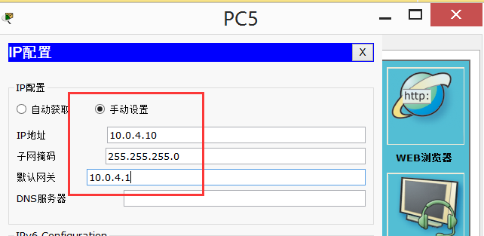

1. 在PC5上对其他主机进行ping测。

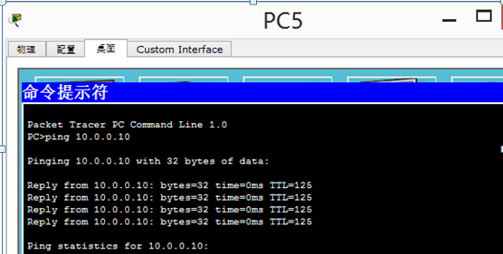

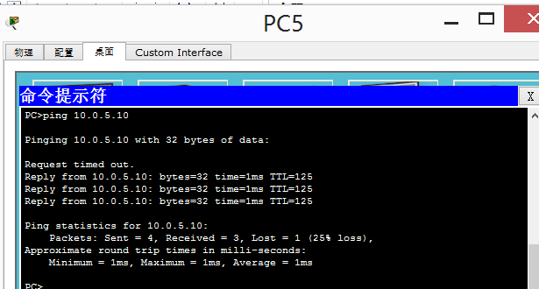

1. **保存配置**
2. 全网设备保存配置，防止掉电配置丢失。

参考配置：

*R1#wr //各设备特权模式下保存配置*

*Building configuration...*

*[OK]*

*R1#*

1. 查看全网设备配置保存是否成功，防止掉电配置丢失。

参考配置：

*R1#show startup-config //特权模式下查看保存的配置*

1. 保存拓扑。

单击“保存”，保存拓扑信息。

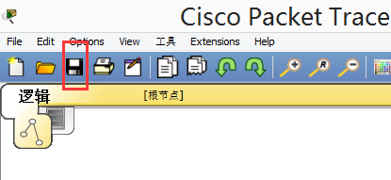

1. 以学号+名字+日期命名拓扑并保存，用U盘带走文件。

